Lab 4
PART 1: Interrupts with the AXI Timer
PART 2: Direct Memory Access

COEN-317
Microprocessor-Based Systems

Derek Saint-Jean
Student ID: 40286262
Simon Guindon
Student ID: 40058301

Lab Section: FL-X

Presented to: Junpeng Gai

Date Performed: November 13, 2025
Date Due: November 27, 2025

Objective
This lab splits up into two parts; the first part involves Interrupts with AXI timer, while the second part involves contrasting direct memory access with CPU transfer of information.
The objective of the first part is to instantiate two timers that will start simultaneously but will have different lengths in such way that the interrupt alarm will be signalled at different frequencies for both timers.
The main objective of the second part is to become familiar with the Xilinx AXI Central Direct Memory Access (CDMA) IP core and its use for high-speed memory-to-memory data transfers on the Zynq ZC702 development board. Specifically, the lab aims to demonstrate how to configure the CDMA in simple mode, connect it to the processor’s AXI interconnects, and transfer data between source and destination arrays in DDR memory without CPU intervention. Another objective is to program the CDMA, poll its status, and verify correct data transfer using a C++ application. Additionally, the lab aims to measure and compare the execution time of memory transfers performed by the CPU versus the CDMA to evaluate the performance improvement offered by DMA.
Theory
For the first part, the main theory involves the usage of timers, similarly to how it was done in lab 3. We will once again use the AXI timer (this time two instances, timer0 and timer1) as a basic timer and counter. The code that we will run will start both timers at the same time with different values. For example, loading the value equivalent to 6 seconds in timer0 and 8 seconds in timer1 will lead to the interrupt to occur at time 6, 8, 12, 16, 18, 24 (twice), 30, 32, 36, 40, 42, 48 and so on. We started by creating a system in XPS that will contain an instance of AXI Timer/Counter with interrupt.
For the second part, the ZC702 development board is built around the XC7Z020 chip, which integrates a dual-core ARM Cortex-A9 processor (Processing System, or PS) with a programmable logic section (PL), allowing for hardware-software co-design. In this lab, the PL is used to implement the Xilinx AXI Central Direct Memory Access (CDMA) IP core to perform high-speed memory-to-memory transfers in DDR memory without CPU intervention.
The CDMA communicates with the processor through memory-mapped registers accessed via AXI interfaces. Important registers include the Control Register (CDMACR) for configuration, the Status Register (CDMASR) to monitor transfer completion, the Source Address (SA) and Destination Address (DA) registers for specifying memory locations, and the Bytes to Transfer (BTT) register to set the transfer size. By writing to these registers, the processor can initiate transfers in simple DMA mode and poll the status register to determine when the transfer is complete.
The CDMA’s master ports are connected to the processor’s high-performance slave ports (HP0 and HP2) through AXI interconnects. This allows the CDMA to read from the source array and write to the destination array directly, bypassing the CPU. An AXI Timer is used to measure the number of clock cycles required for transfers with and without the CDMA, providing a way to evaluate the performance improvement offered by DMA.
Questions
Part 1:
- The program runs as follows: it sets up the timers and loads reset values 0xfc00 0000 at (timer_prt +1)* (thus the load register of timer 0) and 0xf000 0000 at (timer_prt +5)* (thus the load register of timer 1).
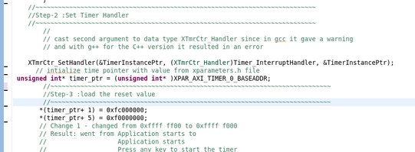
Here, timer_ptr is the base address of AXI Timer0. We then set the timer option to 0x0f4 of both timer0 and timer1. As a result, ENT0, ENIT0, LOAD0, ARHT0, and GENT0 are set to 1 in both timers.
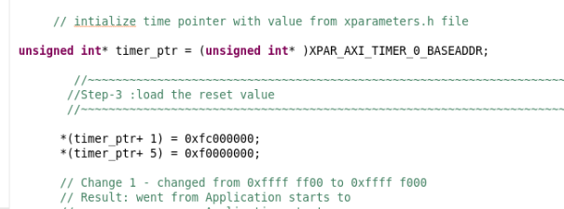
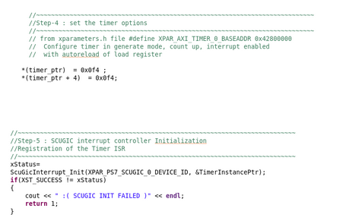
This puts the timers in generate mode with a count up mode, enabled external generate signals, auto reload, with will load value in load register, and enables both timer0 and the interrupt for timer0. We finish by de-asserting the load by writing 0x0d4 to both timers control registers (disabling load will start the timer with our desired settings.)

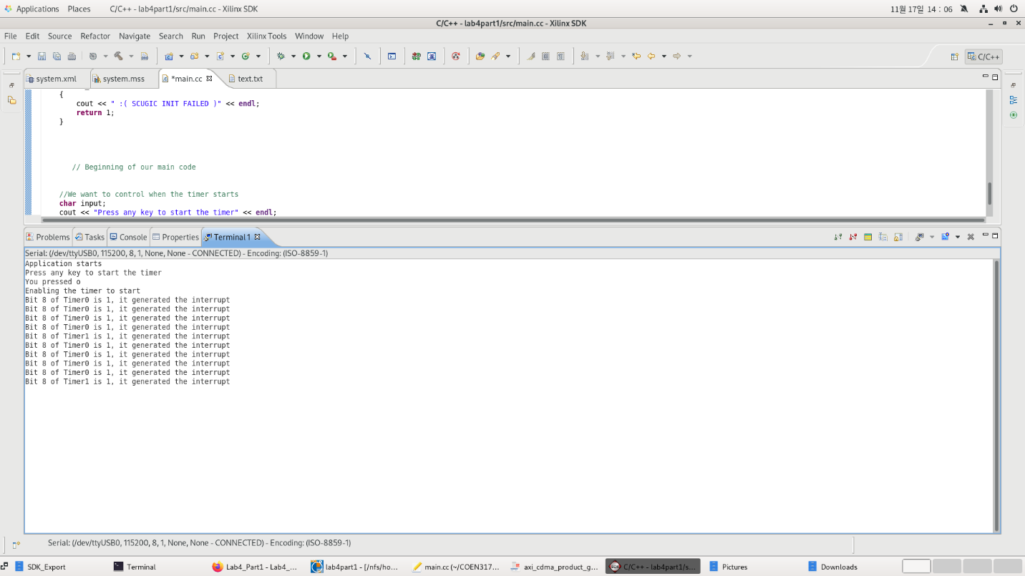

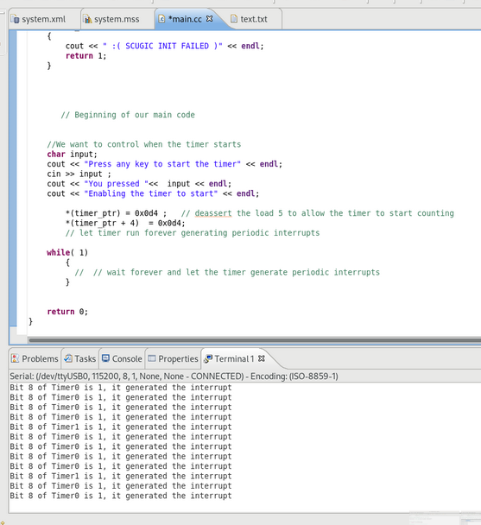
Finally, upon the T0INT/T1INT being set to 1, we enter the interrupt handler function which stop both timer, print which timer caused the interrupt and restart both timers.

Part 2:
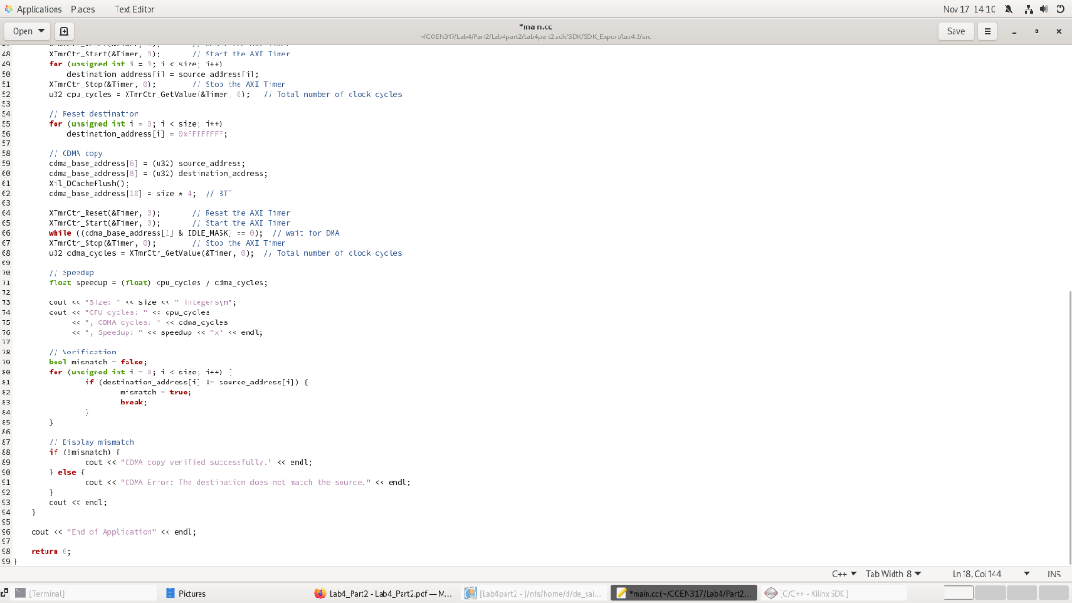
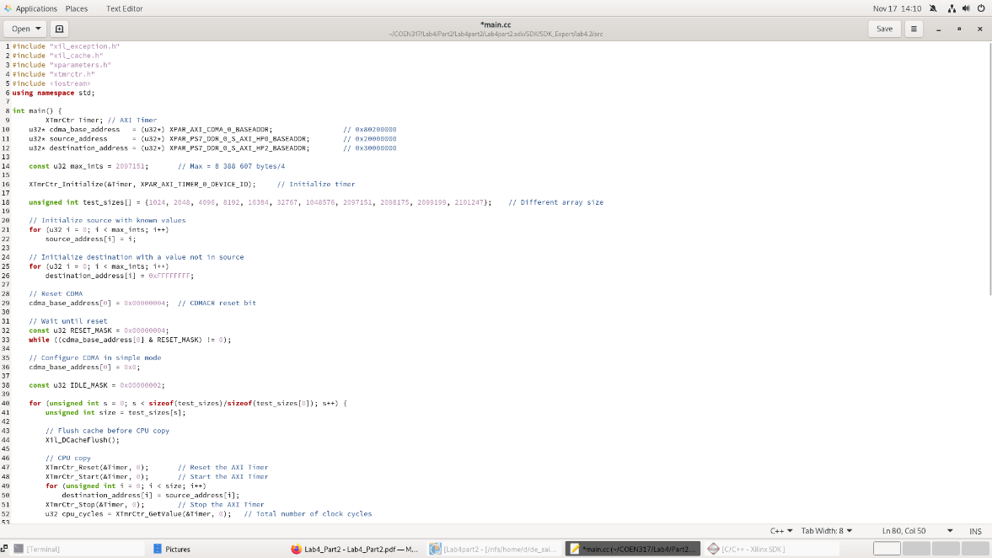
- Add an instance of an AXI Timer to your design (using XPS). Use the timer to measure how long (in number of clock cycles) it takes to transfer the array without using the CDMA and how long it takes to perform transfer using the CDMA. Obtain values for different sizes of the array: 1024 integers, 4096 integers, 8192, 16384, 32767, 1048576, up to a maximum number of integers allowed in one transfer. Compute the speedup given by the use of the CDMA to perform the memory transfer.

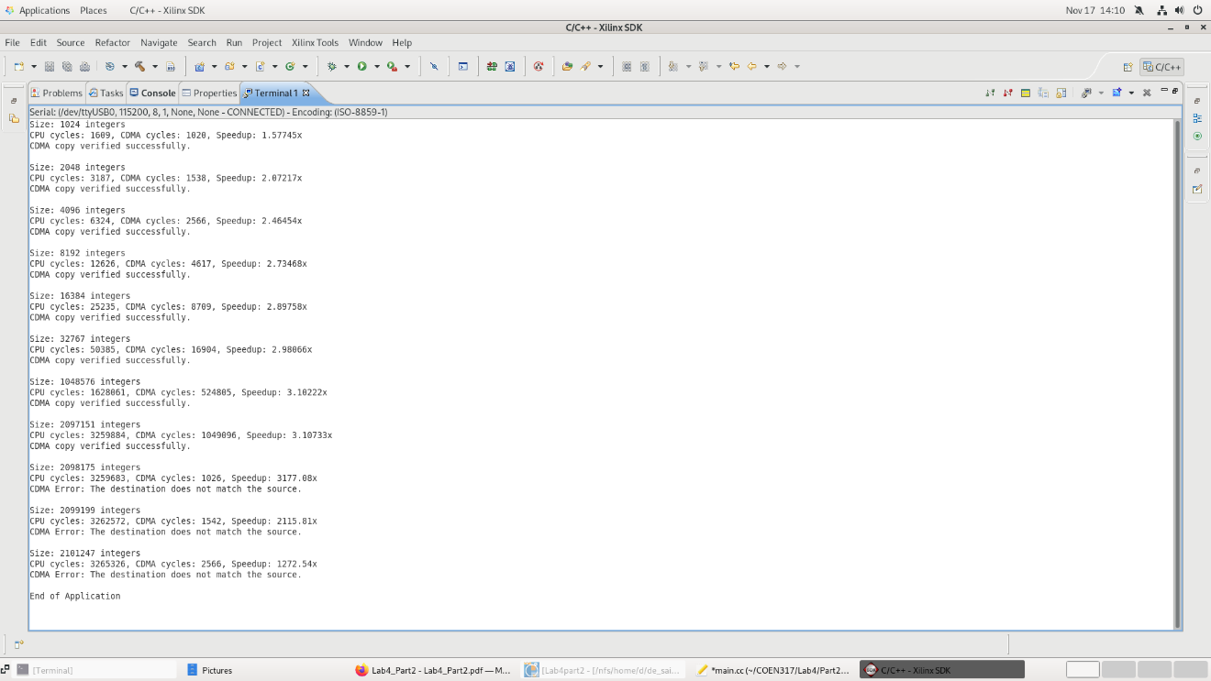
As shown in the Figure above, the speedup given by the use of the CDMA to perform the memory transfer for each array size is:
- 1.57745x for an array size of 1024 integers.
- 2.07217x for an array size of 2048 integers.
- 2.46454x for an array size of 4096 integers.
- 2.73468x for an array size of 8192 integers.
- 2.89758x for an array size of 16384 integers.
- 2.98066x for an array size of 32767 integers.
- 3.10222x for an array size of 1048576 integers.
- 3.10733x for an array size of 2097151 integers.
- 3177.08x for an array size of 2098175 integers, which is greater than the maximum limit of 2097151 integers. So, there is a CDMA error.
- 2115.81x for an array size of 2099199 integers, which is greater than the maximum limit of 2097151 integers. So, there is a CDMA error.
- 1272.54x for an array size of 2101247 integers, which is greater than the maximum limit of 2097151 integers. So, there is a CDMA error.

- What will happen if we program the BTT register with a number which is greater than the maximum allowed?
If the BTT (Bytes to Transfer) register is programmed with a value greater than the maximum allowed by the CDMA core, the memory transfer will not complete correctly. The CDMA may terminate the transfer prematurely, ignore the request, or indicate an error in the status register. Writing an excessive value could also cause the CDMA to attempt reading or writing beyond the intended memory range, potentially corrupting data in DDR memory. The maximum transfer size is determined by the width of the BTT register and the CDMA specification, and exceeding this limit violates the hardware constraints of the device. Therefore, to ensure proper operation and avoid data corruption, the value written to the BTT register must always remain within the allowed range for a single transfer.

Conclusion
In conclusion, Part 1 successfully demonstrated the use of the AXI Timer and the ARM interrupt system on the ZC702 board. The timer was configured to generate periodic interrupts, and the interrupt handler correctly identified the source timer, displayed messages on the terminal, and cleared the interrupt flags. Part 2 showed that the AXI CDMA core could perform high-speed memory-to-memory transfers. Transfers within the hardware limits were verified as correct, and the CDMA consistently outperformed CPU-based copying, providing measurable speedup. Errors occurred when attempting transfers beyond the maximum size, confirming hardware constraints. Therefore, the lab met its objectives by providing hands-on experience with interrupts and DMA transfers, illustrating both software-hardware interaction and performance evaluation on the Zynq platform.

